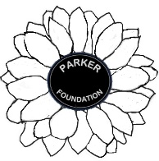**PARKER FOUNDATION**

WE, AT “THE PARKER FOUNDATION”, ARE A COMMUNITY AWARENESS AND FUNDRAISING COMPANY.

P – People

A – Against

R – Raging

K – Killer

E – Evil

R – Rage

The Parker foundation was founded by grand parents and parents of cancer victims.

We here at the Parker foundation started out due to the fact that we lost a grandson to cancer. Through research and development of this platform, we have teamed up with REAL Tournament Solutions which brought to us the concept of helping any charity or development and research of evil diseases and ailments.

With a community-based approach to a national campaign we help get the money into the hands of the people that are trying to make a difference.

We look forward to your help and participation.

Thank you

The Parker Foundation